**Review Meeting- 038**

Gaurang Garg

BioPhotonica Lab, Centre for Biomedical Engineering, IIT Delhi

2025-10-06 (Monday)

**Title:** Improvements of FPM: Technological trends

**Abstract:** FPM achieves higher resolution using reconstruction algorithms on low resolution images. We can bypass the tradition resolution limit using FPM but it still does not meet the requirements of high-resolution biomedical imaging applications, *An Pan et al 2020 Rep. Prog. Phys.****83****096101*. Certain modifications in the hardware or computation are required to solve the issue at hand. Limitations of FPM and their solution are discussed.

# 1. **Introduction**

The resolution *d* of the FPM system is determined by not just $NA_{obj}$ (NA of the objective lens) but also on $NA_{illu}$ (maximum illumination NA of the LED array),

$$d = \frac{λ}{\left(NA_{obj}+NA_{illu}\right)}$$

Where $λ$ is the wavelength of the incident light.

## 1.1. Subsection 1

All equations should be numbered as follows:

|  |  |
| --- | --- |
| $$x=\frac{-b±\sqrt{b^{2}-4ac}}{2a}$$ | (1) |

To write the equation, use the insert > Equation function of a word.

# 2. Figures and Tables

Cite all figures and tables with their respective numbers in the body text. Example: "The OCT signal decreases along the depth, as shown in Fig. 5."

Place the figure caption at the bottom of the figure with all details. For figure caption, use the “Caption style”. Write the caption to be self-sufficient for the reader to understand the details about the figures. For example, see below Fig. 1.

If you include any figures in your report that are from a reference, please write the figure caption like this: "Fig. 2(a) is reprinted from Ref. 3," and make sure to cite the reference properly at the end of your report in the references section.

Place the table caption at the top of the table and cite the table number in the text.

# References:

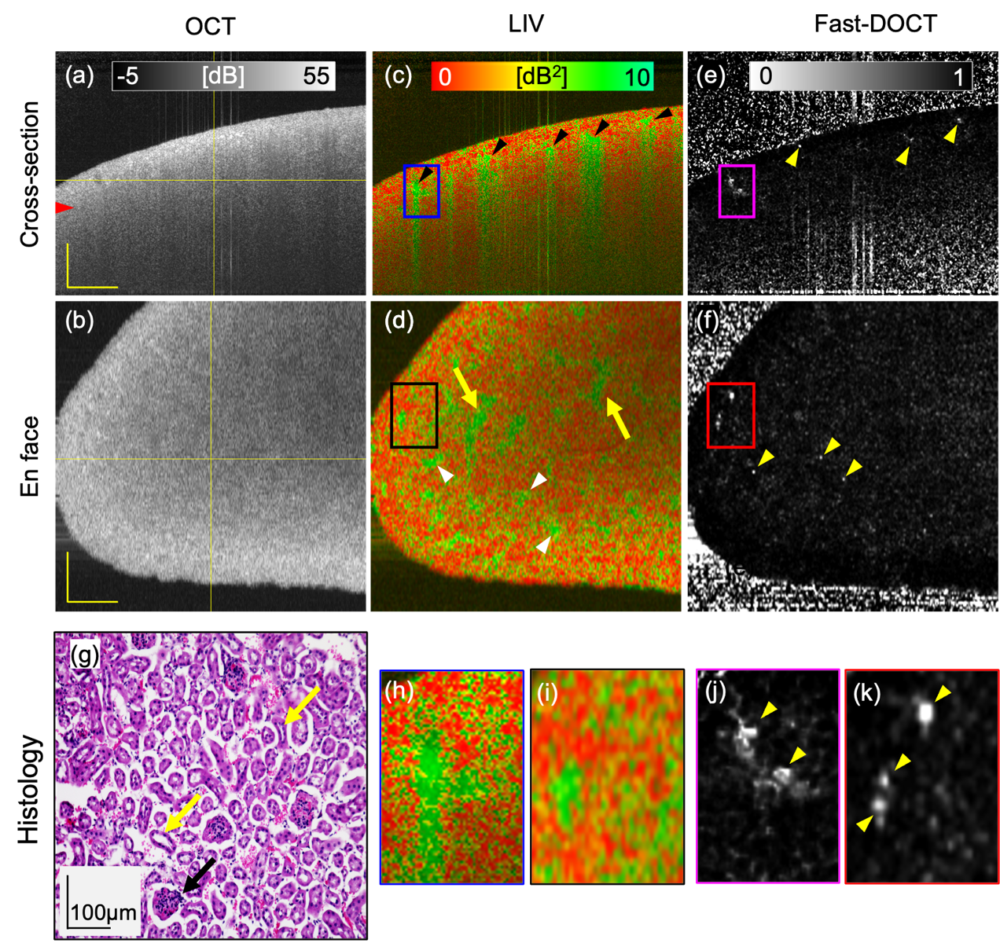

Figure 1: Dynamic OCT imaging of a fresh normal mouse kidney for a 6 mmx 6 mm field of view. Cross-sections from (a) scattering OCT, (c) LIV, and (e) Fast-DOCT imaging; (b, d, f) En face slices of the OCT, LIV, and Fast-DOCT images at the depth location indicated by the horizontal line in (a); (g) H&E stained histological micrograph; (h, j) Magnified images of the LIV and Fast-DOCT cross-section at the region indicated by the rectangular box in (c, e); (i, k) Magnified images of the LIV and Fast-DOCT en face slice at the region indicated by the rectangular box in (d, f). The arrowhead in (a) indicates the depth location of the histology (g). Arrowheads in (c) and (d) indicate the high LIV (green) signals and arrows in (d) represent pipe-like structures. The hyper Fast-DOCT spots in the cross-section and enface are indicated by arrowheads in (e, f, j, k). The black arrow in (g) indicates the glomerulus and the yellow arrows indicate the renal tubules of the kidney tissue. LIV: log-intensity variance; Fast-DOCT: fast dynamic OCT; H&E: Hematoxylin and eosin. Scale bar: 500 µm.

All the claims in the report should be cited with proper references. Use Zotero (Zotero word plugin) to cite references.

See <https://www.zotero.org/support/word_processor_plugin_installation> for details.